NORTHUMBERLAND WEEKEND CHESS CONGRESS 2020

ANTI COVID MEASURES and CONGRESS IMPACTS

NORTHUMBERLAND CHESS ASSOCIATION
Promoting chess in the North East Since 1930

Author : Mick Riding
mickriding@hotmail.co.uk

Contents

1. INTRODUCTION 2
2. KEY BULLET POINTS 2
3. REFERENCES 3
4. ANTI COVID PROCEDURES 3
5. PLAYING SET UP 5
6. IN BETWEEN ROUNDS 6
7. CHANGES TO CONGRESS 6
8. CONCLUSION 7
APPENDIX A – HISTORY OF CHANGES 7
APPENDIX B – ONGOING ACTIONS 7
APPENDIX C – PLAYING ARENA FLOOR PLAN 9
APPENDIX D – MEDICAL CHECKLIST 9

INTRODUCTION

1.1 The purpose of this document is to try and encapsulate all the safety precautions being taken by the Congress in the light of the 2020 Covid-19 (Covid) pandemic and necessary impacts to the congress required to facilitate these.

1.2 The Owner of this document is the Northumberland Congress Tournament Controller.

1.3 The Approvers of this document are –

- North Tyneside Council (NTC) – who will ensure the Congress’ proposals meet Local and Government Covid safety guidelines
- The Chess Playing Community – who will decide by entering or not entering whether the document reflects their own personal safety requirements. It will be a prerequisite of entering that the entrant has read this document. Existing entrants reserve the right to withdraw if on reviewing this document they are not satisfied with the arrangements in place. Entrants should be aware that Government advice is constantly changing and therefore this document will too. It should therefore be constantly referred to.
- The Northumberland Chess Association (NCA) will advise the Owner on measures that may be included and/or enhanced to further consolidate what is being proposed before approving for ratification by NTC.

1.4 Three professional NHS staff are being consulted with respect to some of the anti-Covid steps in this document including

- A Doctor
- A Nurse
- A Radiographer

All of who have had direct contact with patients suffering with Covid since the pandemic arose. Indeed, the nurse still works on a Covid dedicated ward.

1.5 The document will be a work in progress until such time as the Government of the day advises society can fully return to its pre-Covid state. For the purpose of baselining – the version of the document that is active at the time of the Congress will be regarded as the baselined version.

1.6 After the Congress a review will be undertaken and any changes deemed necessary will be reflected. Entrants will be canvassed. The document reviewed by the NCA and NTC will approve.

KEY BULLET POINTS

The document will go into more detail with respect to various issues arising from the Covid threat and playing of chess as proposed in this paper. But because of the seriousness of the threat some key points are being re-enforced here for your specific attention –

- Please do not attend the congress if in the fortnight leading up to the congress you have experienced Covid-19 symptoms or have been living with anyone experiencing the same and not been tested as negative
- Players entering do so at their own risk. We are taking to the mitigation we can but ultimately to enter or not is your decision. Parents of any entrants under the age of 18 will be contacted directly by the congress to provide this assurance.
- The playing environment is single board with no dividers. Although we do adhere to current government guidelines as best we can at any given time. There is no ‘two board’ option.
- Government guidelines are changing every day. Whilst we will try and keep abreast of these and co-ordinate our understanding and any impacts with NTC – you, the entrant, must share this responsibility too.
- The Open tournament is not FIDE rated. All sections are the same playing schedule to support time required for cleaning activity in between rounds.

REFERENCES

NTC, the Congress Organiser and delegated authorities will constantly be referencing https://www.gov.uk/coronavirus?gclid=CjwKCAjwjqT5BRAPEiwAJlBuBYSgaQB68e6ZiDrhHpALYxwkT RXOBTemVFzyKWz8oOwkdGTyaIilEmxoCJIkQAvD_BwE to ensure the proposed protocols continue to adhere to Government Covid-19 Guidelines.

The link https://www.bbc.co.uk/news/uk-51768274 advises of the current Covid situation/statistics in your home area

This document has also used the English Chess Federation Risk Assessment Template https://www.englishchess.org.uk/wp-content/uploads/2020/07/OTB-Chess-Risk-Assessment-v4.pdf
To check completeness.

Finally the author has also referenced the 2020 Irish Championship - https://www.icu.ie/articles/906. Of course there are differences between the Irish protocols and those described here. These are mainly due to timing (Government guidelines when the Irish document was produced), numbers – the Irish championship was looking to accommodate 30 players and duration - for 9 days. An important comparison might be that the Irish tournament was looking to accommodate 30 players at most in 150 sq. metres – the layout the congress depicts will allow 180 Sq. metres for 30 players. The main differences are –
- We are only offering a one board solution (which precludes the need to announce moves) and
- There will be no board dividers

ANTI COVID PROCEDURES

4.1 In the week 2nd – 8th August North Tyneside recorded 3 Covid cases per 100,000 population. The national average is 5. Some areas are higher and subject to local lockdown. An entrant residing in a local lockdown area as of September 11, 2020 will not be allowed to compete. Reference for this is https://www.bbc.co.uk/news/uk-51768274. And of course NTC are monitoring the local situation daily and at any time have the right and power to advise the congress cannot go ahead. The Congress cannot be held legally responsible for any costs incurred in the event of cancellation or prohibition of entrants. Entry fees will, of course, be returned.

4.2 The Congress Organiser will ensure all NHS Track and Trace data has been completed on the entry form prior to the congress commencing and provide it to NTC for that explicit use only. Hotel/temporary residence accommodation will be captured in the lead up to the Congress starting and an entrant cannot play without all his or her track and trace data being provided. At the point when NTC decide it no longer requires the data they will delete their copy and entrants notified so.

4.3 At all times players are expected to be aware of and respect the latest Government guidelines on social distancing. In particular when queuing to enter the playing arena prior to the start of a round.

4.4 The tournament will be held in a playing arena of 32m x 27m – 864 sq. metres. The proposed layout of the arena shows 26.7 sq. metres being required for each ‘batch’ of 6 players. Based on this basic maths the playing arena can accommodate 194 players. The tournament constraint will be 120.

4.5 The tournament hall will be clearly marked to show a one-way system. Within the one-way system there will be no overtaking.

4.6 There will be one main entry to the playing arena. This is a chess congress specific entry only.

There will be one exit from the playing arena.

There will be one specific re-entry to the playing arena. This point is specific to leaving and re-entering the playing arena during play e.g. to access the Rest Rooms. The Congress specific entry must be used to re-enter the playing arena for the start of a new round.

4.7 The wearing of a mask is mandated for playing. We are currently seeking professional guidance as to whether a Visor can be worn with or without a medical waiver.

4.8 A player may additionally wear his/her own protective gloves. If these are disposable, they must be disposed immediately after use and if not then the wearer must observe normal protection measures as if not wearing gloves. We are currently seeking professional guidance as to whether wearing of gloves e.g. disposal should be mandated

4.9 On first entry to the playing arena the competitor

- Will be asked to make a verbal declaration that they have read this document and confirm they are not experiencing any Covid-19 symptoms or living with anyone experiencing the same in the fortnight leading up to the congress
- Will be asked to provide any missing Track and Trace data such as temporary residence details
- Will allow their temperature to be taken by a nominated congress official

4.10 Prior to the congress starting, on conclusion of the congress and in between rounds all playing equipment will be sanitised. Clocks will be programmed at least 72 hours before the start and not touched again until set-up.

4.11 On entering and re-entering the playing arena players must sanitise their hands and (if they are wearing them) gloves.

4.12 Entry and exit points will display sanitising measures required and the playing arena will display government safety posters throughout.

4.13 Each board will be uniquely numbered starting at 1 and organised in that sequence. This is intended to minimise any confusion between Open, Major, Minor boards 1,2,3 etc.

4.14 In readiness for the start of a round players will enter the playing arena through the Congress specific entry point where his/her temperature will be taken. If a competitor registers a high reading on retest e.g. first reading is high and after a rest of ten minutes his/her temperature is still high - 38ºC or above (NHS), he/she will be excluded from the playing arena. After temperature testing the player will advise a designated official of their name and section and will be advised of their board number, colour and opponent’s name. N.B. Of course the player may already have checked this on chess.com as results will be uploaded in a timely manner. But the official will ratify regardless.

4.15 There will be no handshake before or after a game. Players should communicate goodwill by a simple thumbs up, resignation by toppling of their King and offer and acceptance of a draw crossing of arms.

4.16 After two rounds leader boards will be displayed showing the top player in each section and players within a point of the leader to a maximum of 12 players only. Otherwise players will need to reference chess-results.com for specific scores, results etc. The Congress has a projector which might be used pending testing and verifying it will not cause a risk by congregation.

4.17 A number of sheets will be displayed throughout the hall showing tournament scores. These will not be updated during play to discourage players congregating. Again, we will also consider the use of a projector pending assessment and Chess-results.com will be updated as frequently as possible.

4.18 Food cannot be consumed in the playing arena. Players should dispose of their rubbish and a repeat violation (not clearing rubbish) will be excluded from the playing arena.

4.19 No spectating is allowed in the playing area.

- A parent may accompany his/her children of 13 years or younger U14 to their board but once they are settled the parent should leave.
- Players should not leave their seats and browse other games in progress.
- Players should leave the playing arena immediately on conclusion of their game.

4.20 Mobile phones, if brought into the hall, should be switched off completely and left beside the board during play. There will be no bags provided for phones.

4.21 Arbiter announcements between rounds will be relayed over a loudspeaker system

At the completion of the game phones must remain off until the playing hall has been vacated. Anyone failing to do so will have one point deducted from their total score as a minimum punishment. This is necessary not only to avoid disturbance to the player but to avoid any reactions that might cause violation of distancing guidelines.

PLAYING SET UP

The pictures below are simple but hopefully sufficient to depict how individual players, wearing the required protective masks (and gloves if requested) will ‘face off’. The table is 2.2m wide and .8m deep. The distance between players chest to chest is 1.4m. Behind each player will be a 1.5m gap to the next seated player. Players will be grouped in batches of 6, on three tables running North to South. Appendix C of this document will include a full floorplan.

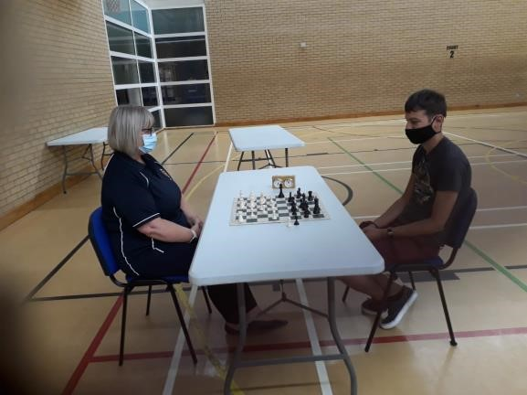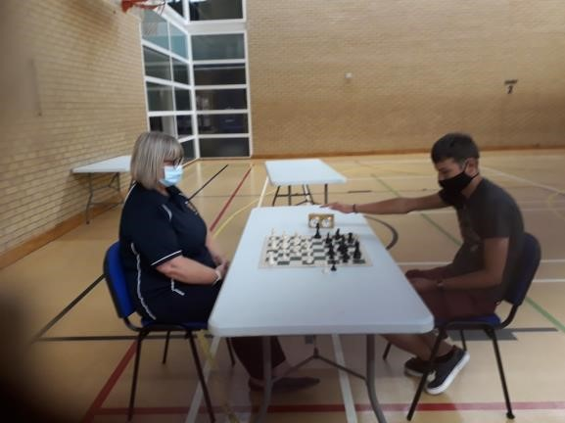

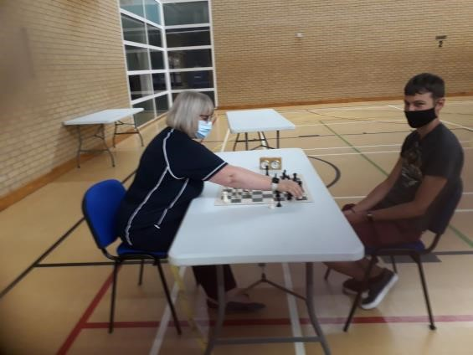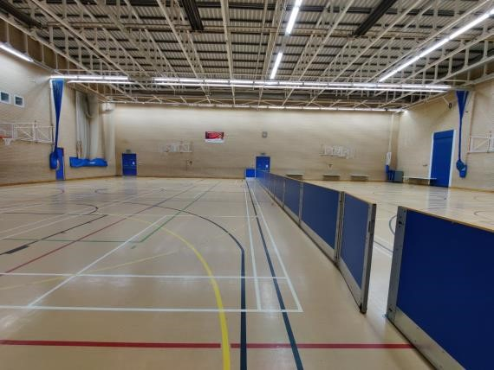

The dividers in the picture will not be there for the Congress and everything you see is the playing area.
Players must record their move before pressing the clock. Including players who continue to record moves despite being below the ‘five minute’ marker. This is to mitigate the risk of transgressing distancing rules when it is your opponents move.
Players must sit back after making a move. Arbiters will monitor this. Anyone refusing to do so (after warnings) will default their current game and further repetition be excluded from the tournament.

IN BETWEEN ROUNDS

Players will not be allowed into the playing hall during the cleaning process.

There are no catering facilities other than vending machines. Players need to source their own.

At the time of writing the Congress has not worked out the logistics of where players may go in between rounds. This is an outstanding action which covers –

- A break out area for lunch and
- An analyse room
- A book stall (conditional on Chess Direct wishing to provide one).

If and when we have provisioned any/all of the above entrants will be advised. Social distancing rules will be displayed at entry points to these areas, including maximum occupancy. They will be monitored and if after reminder individuals continue to ignore guidelines they (the individual) will be barred from using.

CHANGES TO CONGRESS

Administration overhead incurred by the Covid measures mean that –

- All sections will have the same start time and time rates. Therefore the Open Section is no longer FIDE rated
- All sections will have the same Entry Fee and Prize structure
- There will be no Foundation Section this year
- Start times for afternoon rounds are now 2:15 p.m.

CONCLUSION

The weekend event is ever near and as we approach it Government guidelines change daily. However, we need to proceed in the belief it will happen. So as an immediate follow up to this document being reviewed by the NCA Exec and posted to NTC for approval the following actions will be executed –

- Post all existing entrants, potential entrants and Chess Direct with this document ‘as is’ caveated by subject to NTC approval
- Update the Congress entry form with revised schedule, section and prizes
- Complete the floor plan
- On completion of the floor plan produce proposals for accommodating Parents of junior entrants, analysis facilities and a lunch break area
- Continue to monitor and review based on changing circumstance and feedback

APPENDIX A – HISTORY OF CHANGES

Version | Date | Page/Para | Change
00 | 06/08/20 |  | Added Front Page, Contents and Footer
00 | 06/08/20 | 2 | Change Owner to Northumberland Congress Tournament Controller
00 | 06/08/20 | 2 | Added text re medical professionals being consulted
00 | 06/08/20 | 2 | Added Bullet points
00 | 06/08/20 | 3 | Changed instances to 2 in 100,000
00 | 06/08/20 | 3 | Remove ‘5 mile radius’
00 | 06/08/20 | 3 | Enhanced provision of track and trace data to include temporary residence
00 | 06/08/20 | 4 | Wording re wearing of face mask/visor changed
00 | 06/08/20 | 4 | Wording re wearing of gloves changed
00 | 06/08/20 | 4 | Added wording re provision of Track and Trace data on entry
00 | 06/08/20 | 4 | Must sanitise hands and gloves if wearing gloves
00 | 06/08/20 | 4 | Change motion for offer/acceptance of draw
00 | 06/08/20 | 4 | Wording changed re spectating to cover players
00 | 06/08/20 | 5 | Record move before pressing clock
01 | 13/08/20 | Footer | Updated and corrected to 2020
01 | 13/08/20 | Throughout | Replace Bullit with Bullet
01 | 13/08/20 | 2 | Added Bullet Point 1
01 | 13/08/20 | 4.1 | First sentence updated figure and put into better context
01 | 13/08/20 | 4.1 | “An entrant residing in 5” – 5 removed
01 | 13/08/20 | 4.9 | Enhanced Covid declaration criteria
01 | 13/08/20 | 5 | “Appendix A” now C and “map” now floorplan and App C added (though not complete)
01 | 13/08/20 | App B | Remove ‘Last Update’ column from Actions table & just date status updates

APPENDIX B – ONGOING ACTIONS

Num | Action | Date Raised | Status
1 | Create document history | 06/08/20 | Create action log. Done. Appendix B this doc. Close next issue.
2 | Verify appropriate Parks/Council personnel have approved congress | 06/08/20 | Posted requesting verification.  13/08/20 – Parks staff assured they manage events and there will be no ‘higher’ intervention.
3 | Confirm compliance with ECF Guidelines and that games will be graded | 06/08/20 | Posted ECF  13/08/20 – There isn’t any obvious reason within https://www.englishchess.org.uk/wp-content/uploads/2020/08/Tournament-Rules-Aug-2020.pdf why games won’t be graded.
4 | Update Entry Form | 06/08/20
5 | Produce Exec Summary | 06/08/20 | Done – Version 0.1
6 | Consider use of social media to update entrants e.g. text, Mailchimp, WhatsApp | 06/08/20
7 | Ensure all entrants contactable by mobile phone | 06/08/20
8 | Ensure provision of hotel address for Track and Trace | 06/08/20
9 | Get volunteers for cleaning duty and possible support entry into playing arena | 06/08/20
10 | Verify Visor/Mask suitability | 06/08/20 | Awaiting feedback from medical professionals  13/08/20 – Parks staff advised masks preferable
11 | Verify wearing of gloves with NHS professionals | 10/10/20 | Awaiting feedback from medical professionals
12 | Where do ‘High Temp’ people wait? Any provision for parents? | 06/08/20 | 13/08/20 – Parks do not mandate this but we will proceed on basis it provides additional reassurance
13 | Consider producing video showing arrival/entry/playing/exit | 06/08/20 | 13/08/20 – Parks are ok with this
14 | Provide link to document rather than mail out | 06/08/20 | 13/08/20 - Uploaded to NCA website and will be uploaded to Congress website
15 | Identify and contact parent/s of all U18 entrants to ensure they have read and understood this document | 06/08/20
16 | Is Covid testing unit at parks over weekend? | 06/08/20 | 13/08/20 – Not sure, things changing so is this action relevant?
17 | Purchase Thermometer | 10/08/20
18 | Purchase wipes, handwash, gloves, marker tape | 13/08/20
19 | Who cleans playing arena? | 13/08/20 | 13/08/20 - For duration of congress NCA are responsible for ensuring any touch points are regularly sanitised
20 | Await clarification of 30 person gathering rule | 13/08/20 | 13/08/20 – Posted web extract to NTC for conrirmation Congress meets exemptions

APPENDIX C – PLAYING ARENA FLOOR PLAN

Will appear here

APPENDIX D – MEDICAL CHECKLIST

The following is a list of precautions we should be taking from current NHS employees know to the author. One is a Nurse working in a Covid specific patient ward and one a Radiologist coming into contact with 40 patients a day (not necessarily carrying Covid). The author is awaiting 2 GPs to conclude this (albeit) small sample and provide further independent assurance that the congress is taking appropriate care against contracting/spreading infection.

NUM | GUIDELINE | DOC REF PARA
1 | Having experienced wearing PPE of all forms since this unfortunate pandemic started, visors or masks are equally important. | 4.7
2 | A thermometer gun prior entering the building is essential to monitor the temperature of each participant, as all participants will be departing the venue and coming back all the time. | 4.9 third bullet and 4.14
3 | Medical gloves, are important as the virus latches on plastic surfaces. As the pieces are coated with a form of plastic, players will need to wear gloves. | 4.8. Gloves are only mandated for the volunteer team performing cleaning duty in between rounds
4 | Distancing. One meter circle around the chess table AND the player, will need to be maintained throughout the game and round. | 5. Complies with current Government guidelines
5 | Upon finishing the game, players are to exit the building as there is no need for them to be in the building. | 4.19 third bullet.
6 | Players are to stay around their own table only. | 4.19 second bullet
7 | Air conditioning is important, to avoid humidity and damp surroundings, surrounding that can prove breeding grounds not only for the virus but for other ailments as well. Now one can say I do not care if I get a sore throat as I have not symptoms. Well that might be the case, but there is not guarantee you are an asymptomatic carrier that only needs an ailment to fall ill!! | The playing arena is a sports hall with an extremely high ceiling and good air conditioning
8 | Participants not to be ill 14 days prior to the tournament. By ill, I mean cough, temperature, sneezing, cough etc. We do not know whether the participants are asymptomatic carriers or symptomatic carriers. Therefore, by not following this important point, we are all taking an unnecessary risk. | 2 first bullet
9 | Sanitising gel is needed when gloves come off. | 4.8
10 | At beginning of tournament and at the end all pieces will need to be sterilised. | 4.10
11 | Ask people to fill out a short health questionnaire (for example, have you had a temperature or a new cough or loss of smell and/or taste within the last 2 weeks? Have you been in contact with anyone in the last 2 weeks with these symptoms? Have you been in contact with anyone who has been confirmed positive in the last 2 weeks? If yes to any of these turn them away as they would be at risk of spreading the virus.) | 4.9. And leading up to the congress a weekly re-enforced email reminder
12 | Encourage people to use track and trace. | 4.2 and App B Action 8

